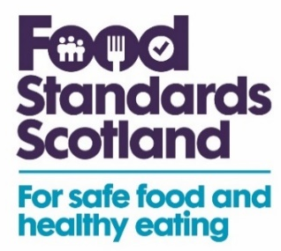

Suggested social media post copy

All formats of video and static assets available to download on the toolkit.

Use Campaign Hashtags: #OnFarmPoisoning #FoodStandardsScotland

Remember to tag us:
- Instagram: @fsscot
- Facebook: Food Standards Scotland
- X (Formerly Twitter): @FSScot
- LinkedIn: Food Standards Scotland

- Food Standards Scotland is urging farmers to be aware of the causes of lead poisoning as herds go out to pasture. Here's a short video to explain more: https://bit.ly/3TKJ8j0

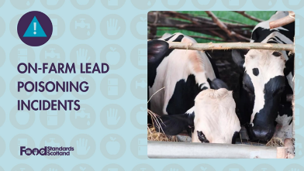 (Video)

- Farmers across Scotland are having to deal with lead poisoning to their livestock. Watch our video to find out what happened to this farmer in Angus. Find out more information about on-farm poisoning at: https://bit.ly/3TKJ8j0

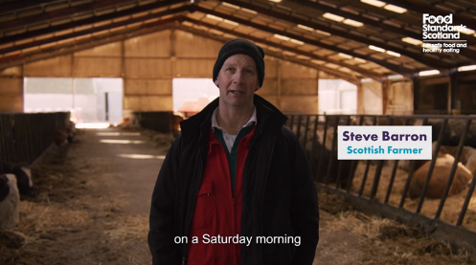 (Video)

- Batteries, bonfire ash, and flaking paint are just some of the sources of lead poisoning that can cause death to farm animals. Find out how to prevent on-farm poisoning at: https://bit.ly/3TKJ8j0

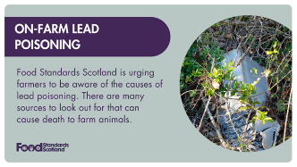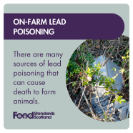

- Around 675 livestock in Scotland have been restricted from the food supply chain due to lead or copper poisoning in the past four years, including over 70 deaths. You can prevent this happening at your farm by following these five simple steps. Find out more information by visiting: https://bit.ly/3TKJ8j0

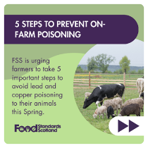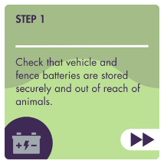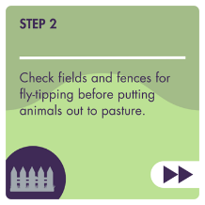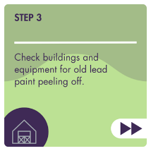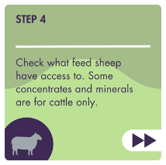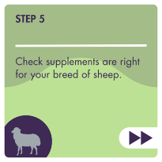

- Abnormal behaviour such as teeth grinding can be a sign of lead poisoning in cattle. Find out more about the symptoms to look out for and how to prevent them by visiting: https://bit.ly/3TKJ8j0

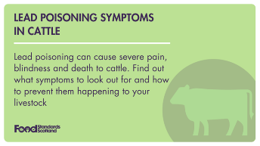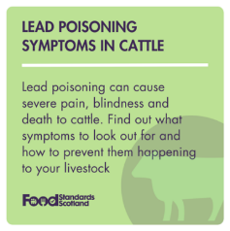

- Lead and copper poisoning are the main causes of on-farm poisoning in farm animals that are destined for the food chain. Find out more ways to prevent this happening to your animals at: https://bit.ly/3TKJ8j0

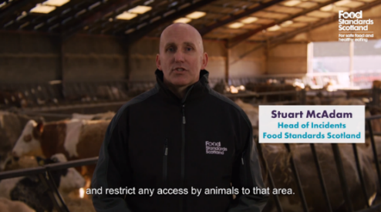 (video)

- A farmer reacts to the aftermath of finding cattle suffering from lead poisoning. Watch our video for the full story at: https://bit.ly/3TKJ8j0

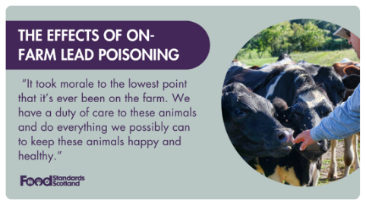

- "It took morale to the lowest point that it's ever been on the farm. We have a duty of care to these animals and do everything we possibly can to keep these animals happy and healthy." A farmer reacts to the aftermath of finding cattle suffering from lead poisoning. Watch our video for the full story at: https://bit.ly/3TKJ8j0

