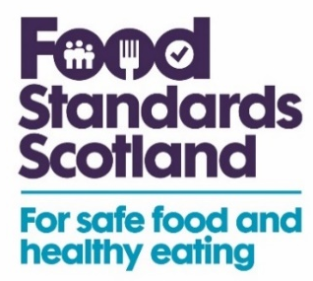

Suggested email, newsletter or website copy

Food Standards Scotland is urging farmers to be aware of the causes of on-farm poisoning as herds go out to pasture.
Around 675 livestock in Scotland have been restricted from the food supply chain due to lead or copper poisoning in the past four years, including over 70 deaths. Farmers can help prevent this happening by following these five steps:
- Check that vehicle and fence batteries are stored securely and out of reach of animals
- Check fields and fences for fly-tipping before putting animals out to pasture
- Check buildings and equipment for old lead paint peeling off
- Check what feed sheep have access to. Some concentrates and minerals are for cattle only
- Check supplements are right for your sheep as breeds such as Texel, Suffolk and North Ronaldsay are more susceptible to copper poisoning.
Find out more about preventing on-farm poisoning at: https://bit.ly/3Vp7HmM

