FSS National feed delivery programme

Sampling Project 2019-2020

Background:

Local Authorities are currently the competent authorities who are responsible for the delivery of official controls for animal feed in Scotland. With budgets and numbers of Local Authority (LA) authorised feed officers in considerable decline, there is a correlating threat to the potential for reduced enforcement this will impact on Feed Law Code of Practice.

Authorities have attributed the difficulties on meeting the requirements of the code to a lack of staff, resources and funding. These difficulties have resulted in a significant reduction in the level of feed inspections being carried out, and the number of feed samples being taken and submitted for analysis. With the number of feed samples taken by LA’s as reduced on average by 21% year on year from 2014-2015 to 2018-19, resulting in only 33 feed samples being taken across Scotland in 2018-2019. Consequently this reduction in sampling is a cause for concern.

The FSS Regulatory Strategy Programme Board has agreed that a recommended option of transfer of competence to FSS with the option to delegate the function, is the most appropriate option and one which is most likely to achieve the improvements necessary to deliver feed official controls across Scotland.

The feed deliver project is working towards the transfer of competence to FSS to take place by April 2021. In order to support local authorities with feed deliver prior to the change in competent authority, FSS has provided LA’s with the option of applying for a sampling grants in the years of 2019-2020 and 2020-2021 for the four priority sampling areas.

Project aim:

The aim of the 2019-2020 sampling project was to obtain information through sampling on the four following priority areas outlined below:

- Priority 1: Raw pet food at retail premises/ manufacturers - Salmonella, Campylobacter, Listeria and E.coli
- Priority 2: Composition of compound feed all Feed Business operators - labelling claims
- Priority 3: Brewers grain - Copper
- Priority 4: Imported grain - Aflatoxins

These priority areas were agreed following feedback from LA’s and guidance from the public analyst’s. Previous historical failures, complaints, business intel, EU exit, new markets and the Public Analyst (PA) testing capabilities were reviewed and evaluated when selecting the priority areas.

Additionally LA’s were given the option of requesting specific sample analyses to be carried out, these are outlined below:
- Additional analyses to be carried out on compound feed for Mycotoxins, heavy metals and salmonella.
- Sample of PAP (feed material for further processing by pet food industry) for heavy metals.
- Sample of Fish Oil for Dioxins.
- Fish Meal for Dioxins, PCBs heavy metals and proximates.

Budget allocation
Each authority was limited to taking a maximum of six samples for each sampling priority. This restriction to six samples was put in place, in order to achieve maximum coverage and proportionate sampling data across Scotland a sample base number of 6 was set per Authority. This would ensure that the project would staff within budget and allow additional follow up work from identified non-compliance.
The total allocation of budget for the sampling grant was £60,000, this allowed for scope of any follow up work that may have been required.

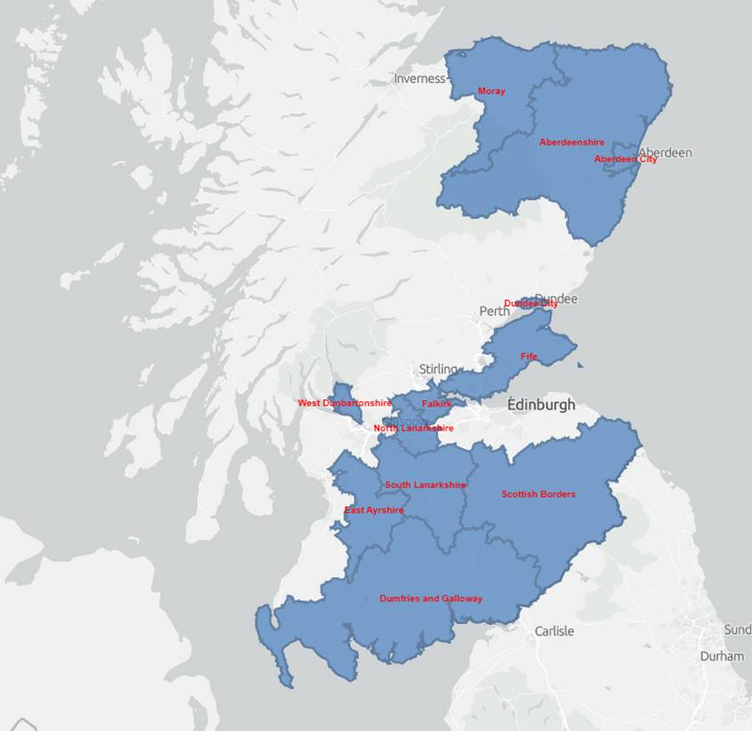
Sampling Area

FSS received grant applications from thirteen authority’s to take part in the sampling grant programme, between October 2019 and March 2020.
The initial number samples expected was 112 samples, covering the four outline priority areas plus the additional 13 samples, totalling 125 samples.
All LA’s and the PA were required to input all records of sampling activities on the Scottish Food Sampling Database (SFSD) and notify Food Standards Scotland, of any difficulties in so doing.

COVID -19 Impact:

Covid -19 impacted the project and this resulted the number of samples analysed being reduced. 69.6% of the samples being completed and reported, additionally some of the LA’s who applied for the grant were unable to submit any samples therefore the geographic area of sampling was also reduced.

- 87 samples completed and reported
- 38 samples not collected

A consequence of the restrictions due to lockdown was that samples not yet submitted by the LA to the PA should not be collected or analysed under the 2019-2020 sampling grant programme.

Consequently when reading this report the constraints of the data due to the reduction in analyses carried out needs to be taken into consideration.

Premises Type:

The sampling was carried out across five premise types percentage representation is shown below.

Sample failures:

In total 28 sample failures occurred during covering both chemical and microbiological failures occurred during the sampling programme In addition 15 samples raised a cause for concern due to either being out with recommended tolerances.
The microbiological areas that are a cause of concern predominately relate to raw pet food, which will be further discussed in section 8 of this report.

Total no sample | Chemical failures as a (%) | Microbiological failures as a (%)
Failures
28 | 82 | 18
Cause for concern
15 | 14 | 86

Chemical - unsatisfactory sample break down (Authors own, 2020)

Microbiological composition unsatisfactory sample break down (Authors own, 2020)

Priority 1: Raw Pet Food

Raw pet food has grown in popularity in recent years. There are a number of manufacturers across the UK ranging in scale from those with international and national markets to smaller producers selling locally. In Scotland there are 53 registered pet food manufactures. There have been a number of feed incidents across the UK in relation to raw pet food due to the presence of Salmonella and Enterobacteriaceae. This included a Scottish family being tested for TB linked to raw pet food as outlined in this press report: https://www.dailyrecord.co.uk/news/scottish-news/family-tested-tuberculosis-cat-dies-16197048

27 raw pet food samples were submitted as part of the sampling programme, 44% of the samples raised cause for concern, in terms of undesirable micro-organisms.

Through the micro- organism analysis undesirable levels of Enterobacteriacea including Ecoli and salmonella, Listeria including L. monocytogenes, and Campylobacter were found.

However the PA’s stated that there are currently no guidelines for the levels of E.coli, Listeria species or Campylobacter in raw pet food, consequently meaning that the samples were highlighted as a cause concern rather than a failure. Therefore it has been noted that this is a policy area to be further developed.

In point 6 of Chapter II of Annex XIII of Commission Regulation (EU) No 142/2011, requirements of sampling raw are outlined as random samples must be taken from raw petfood during production and/or during storage (before dispatch) to verify compliance with standards for Salmonella and Enterobacteriaceae.
Furthermore for the analysis of Salmonella and Enterobacteriaceae five random samples must be submitted to carry out the analysis as per Commission Regulation (EU) No 142/2011.

Due to the structure of the sampling programme, LA’s were asked to submit individual samples therefore, even in the cases were elevated levels of Salmonella and Enterobacteriaceae were found the PA was unable to declare theses samples as unsatisfactory as five random samples were not taken as outlined above.

However, where the elevated levels where found in individual samples the PA have stated that if these results were typical of the batch the samples would be unsatisfactory. The PA additionally stated that all the recorded elevated levels of micro- organisms in the raw pet food samples presents a substantial risk to both animals and to humans through cross-contamination due to exposure to pathogens and potentially a wide range of parasitic organisms, if strict hygiene practices are not followed when handling the product.

In order to continue to build a profile on the raw pet food samples sample results, it is proposed that the sampling plan of 2020-2021 will take the microbiological uncertainty into account. Therefore moving where sampling of raw pet food is carried out under the grant scheme the LA’s will be asked to submitted five random samples of raw pet food as per Commission Regulation (EU) No 142/2011.

Labelling issues:

Of the samples submitted 92% of the samples had some form of a labelling error or could be improved.

A number of sample labels failed to identity the product was ‘raw’ or detail any required storage conditions, in some cases no date or batch codes were apparent on the labels.

Some samples were not labelled as feed materials as required by Article 15 of Regulation (EC) No 767/2009.

This included absent mandatory labelling information along with important storage instructions to ensure an outline of these risks and provide clear, informed advice on how to handle the material to reduce the risk of cross contamination of food intended for human consumption. It was reported some products did provide a list of ingredients however the PA deemed them to be unclear and potential misleading to customers. The sample certificates provided additional analyst comments on rations and claims to allow LA’s to raise and advise manufacturers.

Following these issues raised in the 2019-2020 sampling programme with raw pet food it is proposed that raw pet food will be carried forward as a priority for sampling for the year 2020-2021.

Furthermore FSA have been working on supplying English local authority’s, with a guidance document for sampling Raw Pet food, FSS will review this document and provide the guidance to Scottish LA’s on the sampling procedures of raw pet food. Additional guidance for the sampling and analysis of Raw pet food has also been supplied National Agricultural Panel within the Animal By-Product (ABP) guidance.

Priority 2: Composition of compound feed – labelling claims

The Animal Feed (Scotland) Regulations 2010 provide for the execution and enforcement of Regulation (EC) No. 767/2009 on the placing on the market and use of feed. The EC Regulation sets specific mandatory labelling requirements, which the compound feed samples submitted were assessed against.

The samples taken covered various products for a range of target species including pet food and livestock and fish feed. Of the compound feed samples analysed 27 % failed on labelling claims.

Moisture content: Article 15 of the EC Regulation together with point 6 of Annex I requires that the moisture content of a feed such as this must be declared if it exceeds 14 %, 30% of the failed compound feed samples had moisture contents above 14% and were not declared.

Compositional errors: Annex IV lists permitted tolerances for the compositional labelling of compound feeds, 22% of compound feed samples failed on additive levels and a further 8% failed on other compositional issues.

Failures included levels of both above and below the active threshold.
Above recommended levels of some heavy metals were detected including manganese copper and zinc. Below recommended levels of vitamin A were found in one sample.

One sample had inadequate protein levels and was with the permitted tolerance of 10% as set in Annex IV.
Issues were highlighted in relation to the labelling of some of the product sampled, predominately in relation to ineligible poor eligibility of labels and the failure of the inclusion of batch numbers were required.

Due to the highlighted matters found during the sampling of compound feeds in 2019-2020, compound feeds will remain as a priority for the 2020-2021 sampling grant scheme.

Priority 3: Brewers grain - copper

Two brewer’s grain samples were submitted for analysis of copper following the Commission Regulation (EC) No 1334/2003 of 25 July 2003 amending the conditions for authorisation of a number of additives in feeding stuffs belonging to the group of trace elements. Both samples were checked for copper contamination concerns and both samples received were satisfactory.

Priority 4: Imported grain - aflatoxins analysis

Five samples of imported grain were submitted and analysed in accordance with specific methods are prescribed in the Feed (Sampling and Analysis and Specified Undesirable Substances)(Scotland) Regulations 2010 for Aflatoxin B1, B2, G1 and G2, no statutory statements were submitted with the samples. All sample results were satisfactory, post EU exit import sampling will remain a national feed priority. It is likely there will be additional Border Control Posts (BCP) in Scotland triggering increased surveillance and sampling intervention.

Additional analysis

Additional analysis was requested by Aberdeen City and Fife with identified concerns raised around these specific areas. Food Standards Scotland agreed that these were significant and proportionate requests that met with national feed priorities.

Aberdeen City submitted 2 samples of fish meal for dioxins, PCB’ heavy metals and proximate analysis was carried out, both samples were satisfactory.

Fife submitted 2 samples of Soya bean meal and 1 sample of soya hull pellets, this was in response to the Port of Rosyth obtaining BCP status, and importing soya from Argentina. All samples were analysed for Cadmium and Lead as well as Aflatoxins, all samples confirmed satisfactory results.

2020 -2021 Sampling Plan

On the 21st of October the LA’s were invited to submit sampling grant applications for the year of 2020-2021.

Currently the plan is to re run a sampling grant programme with samples being collected and submitted in quarter 3 and quarter 4, however due to the current circumstances, this will be reviewed prior to any grants being given and will be regally reviewed through the sampling programme.

Following discussions with LA’s and PA alongside reviewing the results from the 2019-2020 sampling programme the proposed four priority sampling areas for 2020-2021 year are outlined below.
Similar to the previous year any requests for additional sampling will also be considered.

Raw Pet food – microbiological exam

Imported feed – Aflatoxins

Compound feed – compositional analysis

Salmonella in animal feed - (non pet food)

