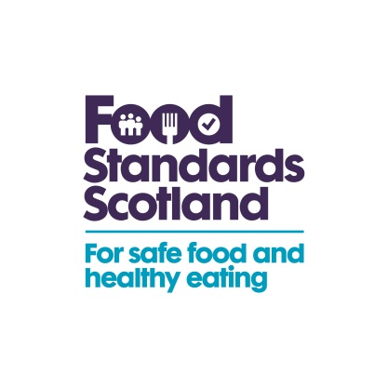 | T: 01224-288357  M: 07824 342187  E: Patrick.Smyth@fss.scot

To: Heads of Service and Lead Food Officers in Scotland

18th April 2016 Ref: FSS/ENF/16/005
Dear Colleagues,

EXPORTS OF FOOD PRODUCTS TO CHINA –

RESUMPTION OF LIVE CRABS EXPORT TO CHINA

A ban on the export of live crabs to China has been in place since last year, due to issues around compliance with the Chinese regulations on Cadmium levels. However, Defra have now confirmed that the Chinese authorities (AQSIQ) have agreed to lift the restrictions on the export of live crabs from the UK following their agreement to a revised sampling and testing regime for exporting food businesses.
In view of this new development, and with effect from 13 April 2016, the Animal and Plant Health Agency (APHA) have now released Export Health Certificate (7432EHC) to businesses for sign-off by local authority inspectors based on new Notes for Guidance (7432NFG) and Standard Operating Procedures (SOP).
Under the new arrangements, food businesses will be required to provide Local Authorities with additional information on the sampling and test results for Cadmium levels and the areas from which those crabs have been caught.

Defra has provided the following additional information:

“The notes for guidance (7432NFG) for the export health certificate for the export of live aquatic animals, excluding bivalve molluscs to the People’s Republic of China (7432EHC) have been revised and agreed today. They have now been released by APHA at Carlisle for use by exporters and Local Authority Inspectors.

A standard operating procedure (SOP) for exporters and Local Authorities has also been developed.

We anticipate that the Local Authority Inspectors providing export certification may have some questions about some aspects of this trade and below is some clarification on some particular points:

1. Fail-tolerance limit for cadmium: At paragraph 10.1 of the notes for guidance there is mention that testing for cadmium must be carried out on crabs caught for export to China. The testing will be carried out on the basis of catch areas. Defra will decide if the test results exceed the fail/tolerance limit for export to China. At present all fishery areas are approved and Defra has taken the decision that no fishery areas have exceeded the fail/tolerance limit for cadmium. If Defra does decide that any of the fishery areas have exceeded the fail/tolerance limit for cadmium in the future, then this will be communicated by APHA to FSA/FSS and onward to LAs. Until then LA inspectors can assume that all fishery areas around the UK are approved for the catching of crabs for export to China.

2. New exporters: LA Inspectors should be aware that exporters of crabs to China must be listed by AQSIQ. The procedure is set out at paragraph 4 of the Notes For Guidance (NFG).

3. Any new exporters must also comply with the sampling and testing requirements set out at paragraph 10 of the NFG (and also included in the SOP). If this is not done independently, the exporter can demonstrate testing by joining the sampling and testing scheme which is set out in the NFG and SOP. It is worth pointing out that it is likely that sampling and testing costs will be cheaper under membership of the SAGB scheme.

4. Revising the NFG again: We are aware that the NFG is too long and that there is a considerable amount of duplication in the SOP but for expediency we have released the NFG and SOP as they are. We will revise both documents as soon as we can.”

A copy of the revised Notes for Guidance (7432NFG) is attached and the SOPs are available from the Seafish website at http://www.seafish.org/media/publications/UK-LA-SOP-CRABS-TO-CHINA.pdf.

Defra will keep the attached webpages up to date with any further developments https://www.gov.uk/imports-and-exports-of-animals-and-animal-products-topical-issues.

If businesses have any further enquiries concerning this subject matter, they should be advised to contact the Animal and Plant Health Agency (APHA) Centre for International Trade, Carlisle: liveanimalexports.carlisle@apha.gsi.gov.uk or Tel: 03000 200301.

Should you require further advice on the content of this letter, please contact me

Yours sincerely
Patrick Smyth
Senior Environmental Health Manager
Food Standards Scotland

