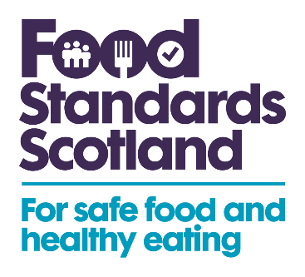
Christmas Campaign: Social Media Copy

The following is suggested copy to include across your social channels alongside the social media images provided.

This Christmas, no one wants to end up with food poisoning. @FSScot have made a checklist to help remind you of some easy food safety practices for this time of year. Find out more: https://bit.ly/3I4Ahk9

Learn more about the importance of storing and preparing food safely during the Christmas period – and find some simple food safety practices – on this @FSScot checklist: https://bit.ly/3I4Ahk9

Christmas can be a magical time of year, but not if you end up with food poisoning! Food Standard Scotland created a checklist of some easy food safety practices to help you reduce this risk. Find out more: https://bit.ly/3I4Ahk9

