Appendix 9. Simulation Methodology

Section 9.1. Nutrient composition and frequency of reported consumption of food items included in composite foods for simulated replacements

 | Energy  (kcal/100g) | Protein  (g/100g) | Calcium  (mg/100g) | Iron  (mg/100g) | Iodine  (µg/100g) | Selenium  (µg/100g) | Zinc  (mg/100g) | Vitamin B₁₂  (µg/100g)
Pulses and legumes | 128 | 5.8 | 40 | 1.6 | 2.7 | 3.1 | 0.8 | 0.0
Vegetables | 79 | 3.5 | 38 | 0.9 | 2.8 | 4.2 | 0.6 | 0.0
Egg | 177 | 13.0 | 53 | 1.8 | 52.8 | 24.5 | 1.2 | 2.4
Oily fish | 234 | 22.3 | 45 | 0.6 | 19.9 | 22.8 | 0.7 | 4.5
Plant-based meat alternatives | 144 | 11.6 | 142 | 1.6 | 4.6 | 4.0 | 3.1 | 0.2
Plant-based milk drinks | 32 | 1.3 | 70 | 0.3 | 3.0 | 1.1 | 0.3 | 0.1
Minced beef, stewed | 177 | 24.7 | 14 | 2.3 | 10 | 8 | 5.6 | 2.7
Chicken breast, fried | 166 | 31.2 | 6 | 0.4 | 7.0 | 16.0 | 0.8 | 0.0
Ham, not smoked | 131 | 20.0 | 7 | 0.7 | 3.0 | 11.0 | 1.9 | 0.7
Tomato, fresh | 14 | 0.5 | 8 | 0.2 | 2 | 0 | 0.1 | 0
Tomatoes, canned (pureed) | 19 | 1.1 | 11 | 0.6 | 2 | 0 | 0.1 | 0
Carrots | 29 | 0.5 | 31 | 0.3 | 0 | 0 | 0.1 | 0
Peas, cooked from frozen | 71 | 5.7 | 36 | 1.8 | 2 | 0 | 0.8 | 0

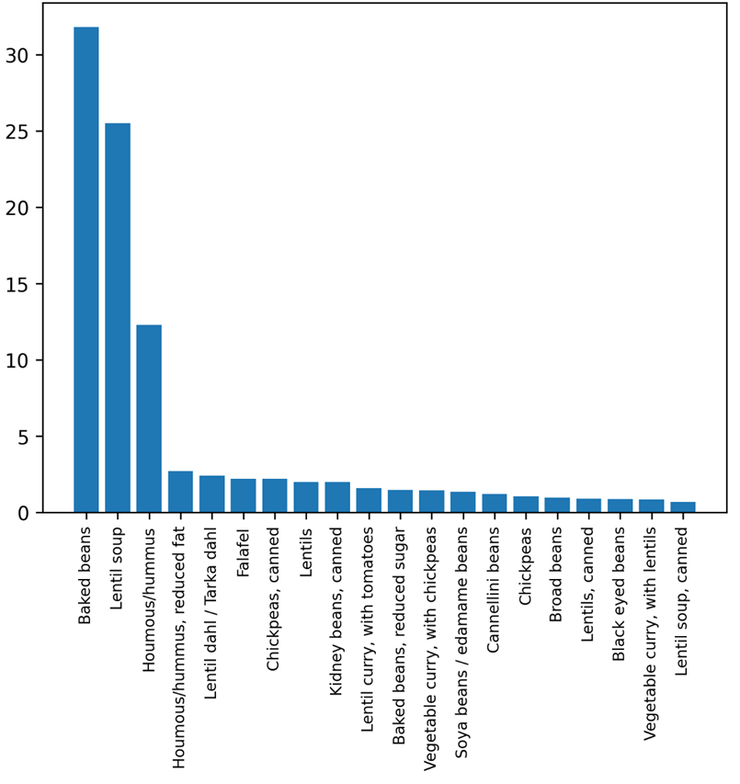
Figure A9.1. Percent of specific pulses and legumes contributing to pulses and legumes consumption among adults (16+y) living in Scotland. For example, just over 30% of pulses and legumes consumed are consumed as baked beans, about 25% as lentil soup, etc.

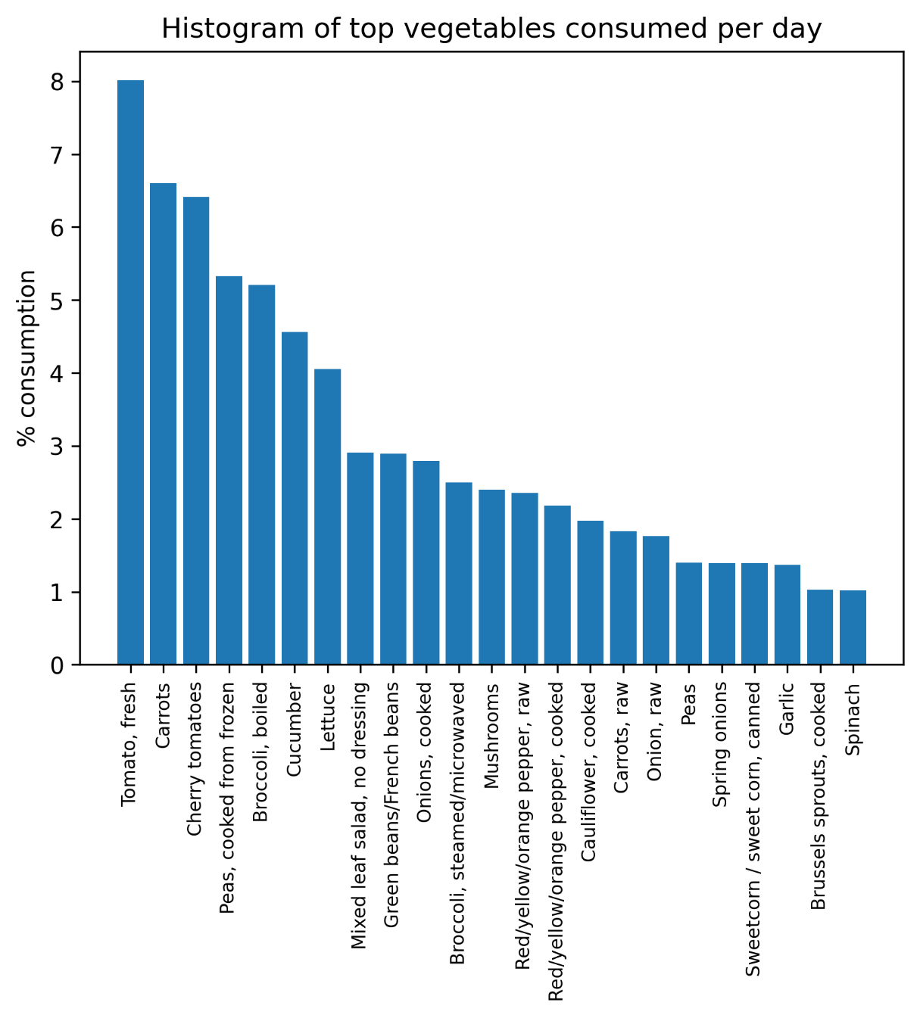
Figure A9.2. Percent of specific vegetable types contributing to vegetable consumption among adults (16+y) living in Scotland. For example, about 8% of vegetables consumed are consumed as fresh tomatoes, about 6.5% as carrots, etc.

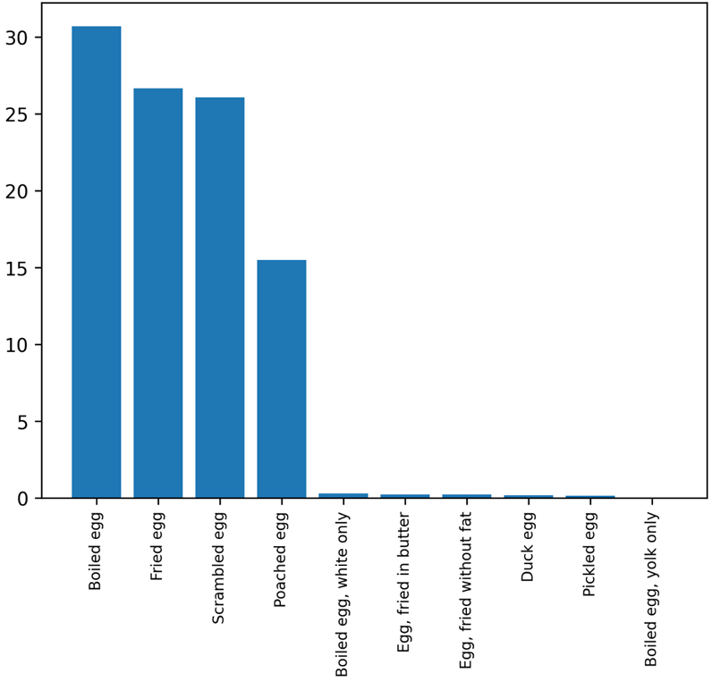
Figure A9.3. Percent of specific egg types contributing to egg consumption among adults (16+y) living in Scotland. For example, about 30% of eggs consumed are consumed as boiled eggs, about 25% as scrambled eggs, etc.

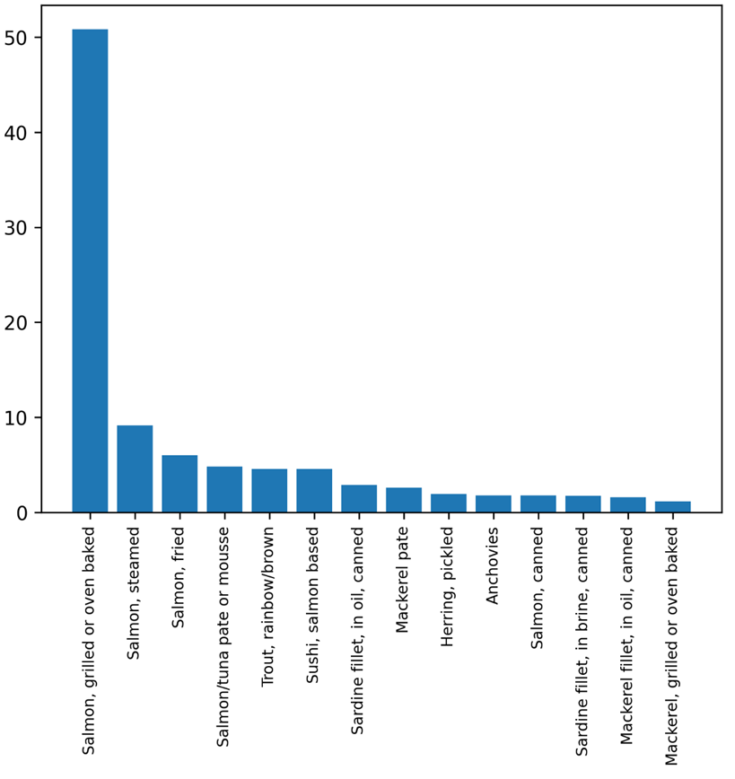
Figure A9.4. Percent of specific unsmoked oily fish types contributing to unsmoked oily fish consumption among adults (16+y) living in Scotland. For example, about 50% of unsmoked oily fish consumed is consumed as grilled or over-baked salmon.

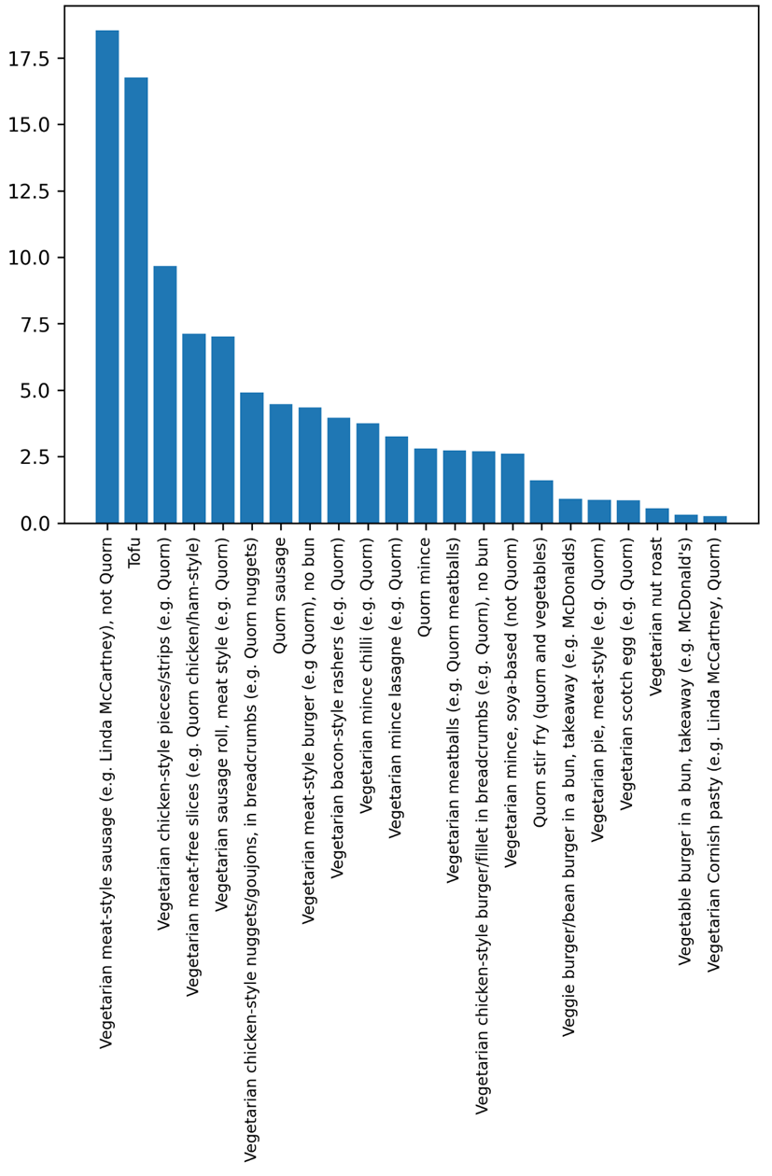
Figure A9.5. Percent of specific plant-based meat alternatives contributing to plant-based meat alternative consumption among adults (16+y) living in Scotland. For example, about 18% of plant-based meat alternatives consumed are vegetarian meat-style sausages (e.g., Linda McCartney), not Quorn.

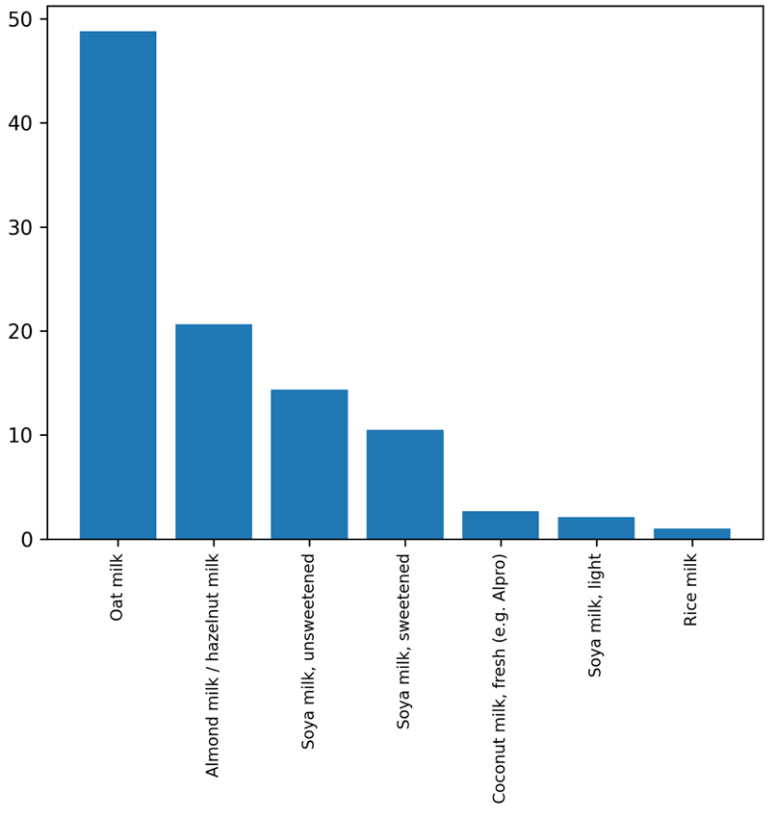
Figure A9.6. Percent of specific plant-based milk drinks contributing to plant-based milk drink consumption among adults (16+y) living in Scotland. For example, about 50% of plant-based milk drinks consumed are oat milk drinks.

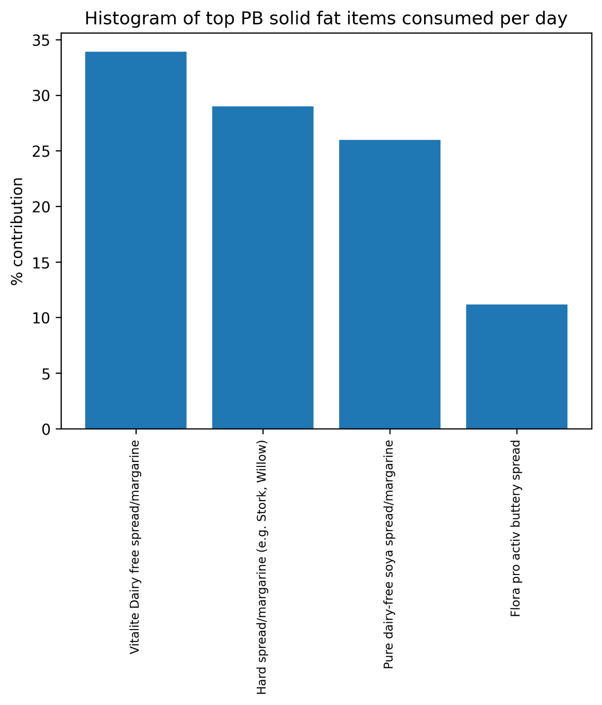
Figure A9.7. Percent of specific plant-based solid fats contributing to plant-based yoghurt consumption among adults (16+y) living in Scotland.

Section 9.2. Methodology for simulation of impact on nutrient intake

The nutrient intake of all respondents from the 2021 round of the Scottish Health Survey (SHeS) was computed to determine baseline intake. Three reduction scenarios were considered: fixing maximum daily intake of unprocessed and processed red meat to 70g/day, 60g/day and 31g/day, each combined with a 20% reduction in all dairy. The nutrients from all items affected by the reduction were subtracted from the baseline intake. As the reductions in unprocessed and processed red meat only apply to those consumers who consume above the threshold, those that consume below the threshold do not experience a change in nutrient intake from the reduction in meat. Furthermore, for those consumers that consume both unprocessed and processed red meat, there are multiple combinations of reductions were the threshold could be reached, depending on whether unprocessed red meat was reduced, processed red meat was reduced or a combination of both. In such cases, random sampling was used to reduce either the unprocessed red or processed red meat intake in 10g increments until the maximum intake was reached. The estimates for the change in nutrient intake provided in the report are the average across different combinations of reducing unprocessed red or processed red meat. As the dairy reduction is a fixed 20% reduction applied to all items no such sampling was required. Furthermore, as this reduction is applied regardless of consumption level, those with a higher baseline intake of dairy experience a greater drop in nutrient intake than those with a lower baseline intake of dairy.

Two reduction methods were employed: whole item level reduction and reduction of a food group within a composite dish (Figure A9.7.). In the first method, the intake of the whole item was reduced by a specified percentage, with this reduction therefore affecting all nutrients contained in the food item. This method was applied to all meat and dairy items that were not an ingredient in a composite dish as well as to all offal containing items.

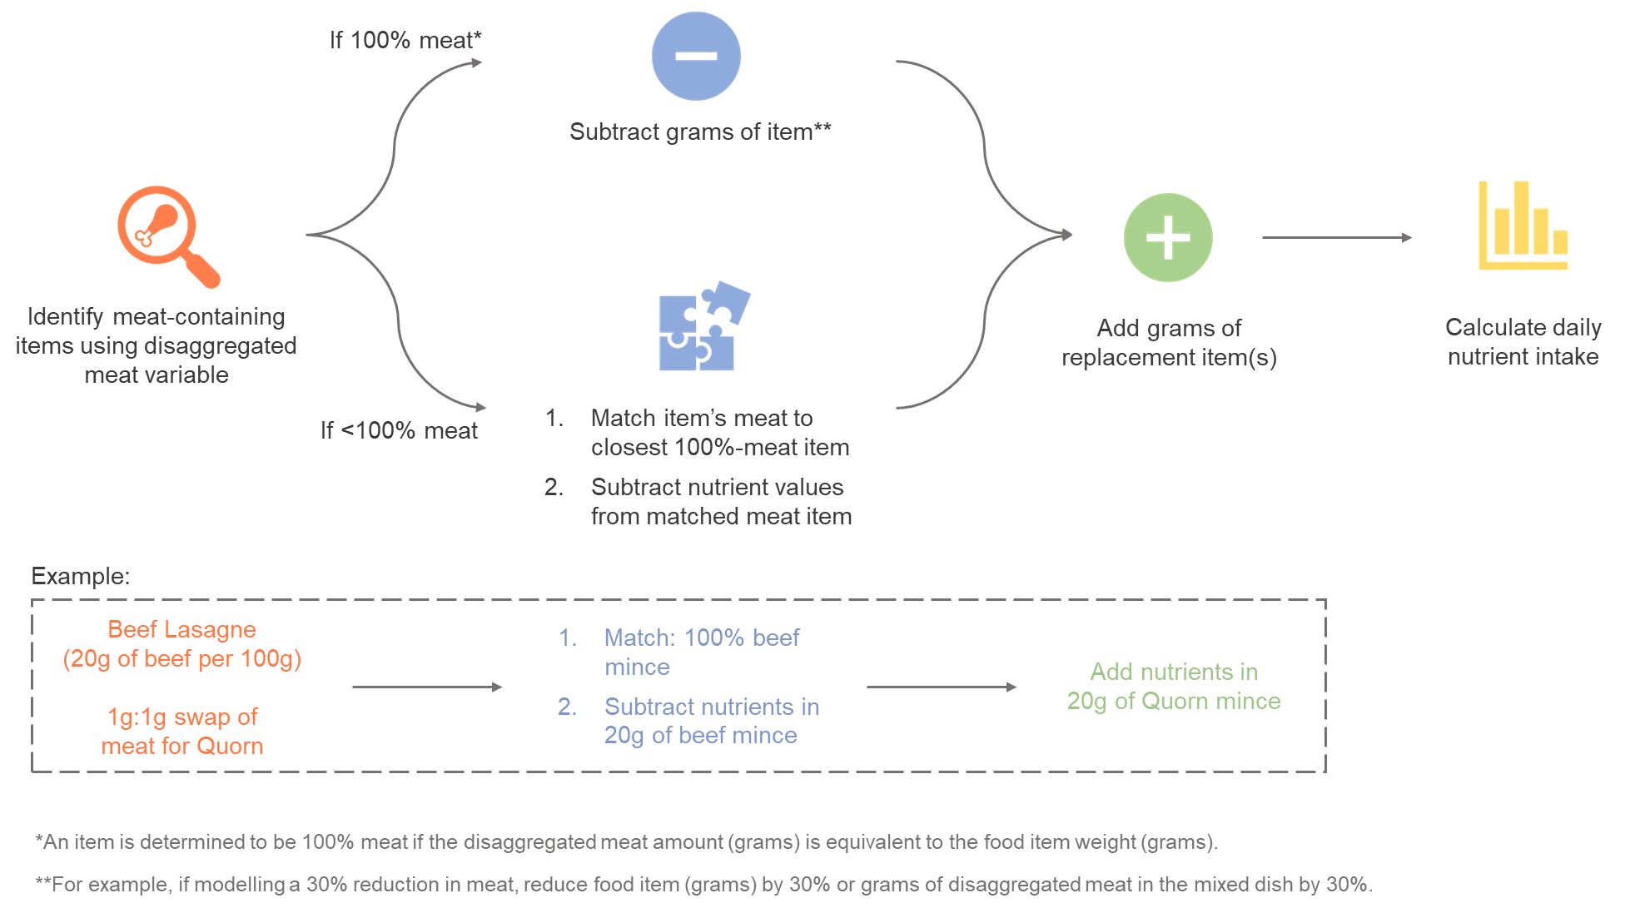
Figure A9.7. Modelling approach for reducing meat and meat-containing items.

The second reduction method was applied to all dairy containing items and the meat content of composite dishes. A separate analysis was conducted to determine the quantity of each dairy food group in all dairy-containing items from the FSA recipe database. In addition, the percentage contribution of each ingredient within each dairy food group to the total quantity of that dairy food group was computed. To take an example of how the dairy reduction works in practice, say the 20% reduction resulted in a 10g reduction in semi-skimmed milk intake for a particular item, and this item contained two different semi-skimmed milk ingredients with a different nutrient content which each comprise 50% of the total semi-skimmed milk content of the item. The change in nutrient intake is then computed by subtracting the nutrient content of 5g of each semi-skimmed milk ingredient. Should this item have only contained a single semi-skimmed milk ingredient, the change in nutrient intake would be the nutrient content per 10g of the single semi-skimmed milk ingredient. This process is repeated for all dairy food groups.

It was not possible to extract the nutrient contribution from the meat alone within a composite dish. Each meat-containing item was therefore matched to a non-composite meat item that most resembled the meat item within the composite dish. Each match was independently verified to ensure that the matches were appropriate. The nutrient content per gram of each non-composite meat item was then computed, before multiplying by the gram weight of the Intake24 disaggregated meat category. For example, 100g of “Cottage pie (beef), home made” contained 19g of the disaggregated beef category ‘Beefg’. The non-composite beef item “Minced beef, stewed” was assigned as the closest match for the meat type within “Cottage pie (beef), home made”. In the case of a 20% reduction, the amount of beef per 100g decreases by 20% of the beef content of the dish which would results in a 3.8g decrease in the beef content in 100g of “Cottage pie (beef), home made”. To quantify the decrease in nutrient intake from this reduction, the gram weight of the reduction is multiplied by the nutrients per gram of the non-composite match item before subtracting the result from the nutrient content of the whole item. In this example, 100g of “Cottage pie (beef), home made” contains 7.1g of protein, arising from all ingredients within the composite dish. One gram of “Minced beef, stewed” contains 0.25g of protein, and therefore the 3.8g decrease would result in a decrease of 0.95g of protein. The final protein content of the composite item “Cottage pie (beef), home made” following the 20% reduction in beef would therefore be 7.1g – 0.95g = 6.15g of protein. This procedure is applied to all composite items with non-zero disaggregated meat categories and to all nutrients.

Following the reductions, the nutrients from the substitution items were added. Each substitution was assumed to act on a per gram basis. The added nutrients were equal to the nutrients per gram of the substitute, multiplied by the gram weight of the reduction of either the total grams of the item in the case of whole-item level reductions or the gram weight of the disaggregated meat variable in the case of meat reductions.

The substitutes for the meat or dairy items consisted of a weighted average composition of the most frequently reported items within a food category. Milk items were replaced by plant-based milk drinks, with the nutritional profile of the plant-based milk drink substitute consisting of a weighted average of the most frequently reported plant-based milk drink items in the SHeS dataset. Solid fat dairy items were similarly replaced with plant-based solid fat items. In the case of substitution by pulses and legumes, oily fish, eggs and plant-based meat alternatives the substitute consisted of a weighted average combination of the most frequently reported dishes that contained each substitute in the SHeS dataset. As a result, we also include any nutrients from, for example, the non-pulse component of a pulse and legume replacement such as the sugar in baked beans, or the pastry in a vegetarian sausage roll in the plant-based meat alternatives replacement. Such a choice is motivated by the fact that consumption of the whole food item is more realistic following a reduction in meat consumption than the consumption of the non-composite replacement (e.g., chickpeas vs. houmous). As a consequence, only 44% of the pulse and legume composite replacement consisted of the Intake24 beans disaggregated variable. Items that were consumed by <1% of the population were not included in the weighted composite. In the case of oily fish, we further removed any items that included the term “smoked” in the description. In some instances, the nutrients per gram of individual food items contained small differences within each food item with, for example, the nutrients per gram in “baked beans” slightly differing between different responses of baked beans. In such an event we took the average over the nutrients in a single food item before adding this average to the composite. With regards to vegetables, given the much larger set of composite items that contained vegetables, in this instance we restricted the replacement a weighted composite of the most frequently reported non-composite vegetable items (e.g., “Tomatoes” and “Carrots”).

Both the absolute new intake for each nutrient was computed as well as the change in the nutrient intake compared to the baseline intake. The new levels of nutrient intake were compared among different demographic groups based on age group, gender, age group and gender, BMI group, and SIMD quintile. BMI data were missing for 291 respondents (~8% of the total) which were imputed using a model based on age, ethnicity, and whether the respondent consumed meat. The impact on the SDGs from each of the scenarios was also derived.

